ROLLNO : 240701569

EXPERIMENT 9
Design input forms that validate data and display error messages using HTML, CSS, and JavaScript.
AIM:
To design an input form that validates user data such as email and phone number and displays appropriate error messages.
PROCEDURE:
Step 1: Create and Design Form
Create an HTML file and design a form with input fields for email and phone number along with a submit button.
Step 2: Apply Styling
Apply CSS styling within the same file to improve the appearance of the form using a themed user interface.
Step 3: Add Validation
Use JavaScript and Validator.js within the same file to validate user inputs and display error messages when invalid data is entered.
PROGRAM:
<!DOCTYPE html>
<html>
<head>
<title>Form</title>

<style> body { margin: 0; height: 100vh;
display: flex;
justify-content: center; align-items: center; font-family: 'Segoe UI';

/* beach sky + sea */
background: linear-gradient(to bottom, #87ceeb, #00b4d8);
}

/* main box */ .box { width: 300px; padding: 30px; border-radius: 20px; text-align: center;

/* sand color */
background: linear-gradient(to bottom, #fff, #fefae0);

box-shadow: 0 10px 30px rgba(0,0,0,0.2);
}

/* title */ h2 { color: #0077b6; margin-bottom: 20px;
}

/* inputs */
input { width: 100%; padding: 12px; margin: 10px 0; border-radius: 12px; border: none; outline: none; background: #e0f7fa; font-size: 14px;
}

/* button */ button { width: 100%; padding: 12px; border: none; border-radius: 12px;
background: linear-gradient(to right, #00b4d8, #0077b6); color: white; font-weight: bold; cursor: pointer; transition: 0.3s;
}

button:hover { transform: scale(1.05);
}
/* error */ small { color: #d00000; font-size: 12px;
}
</style>

</head>

<body>

<div class="box">
<h2>Form</h2>

<form id="form">
<input type="text" id="email" placeholder="Enter Email">
<small id="emailError"></small>

<input type="text" id="phone" placeholder="Enter Phone">
<small id="phoneError"></small>

<button type="submit">Submit</button>
</form>
</div>

<script
src="https://cdnjs.cloudflare.com/ajax/libs/validator/13.6.0/validator.min.js"></sc ript>

<script>
document.getElementById("form").addEventListener("submit", function(e) { e.preventDefault();

let email = document.getElementById("email").value; let phone = document.getElementById("phone").value;

let emailError = document.getElementById("emailError"); let phoneError = document.getElementById("phoneError");

emailError.textContent = ""; phoneError.textContent = "";

if (!validator.isEmail(email)) {
emailError.textContent = "Invalid email!";
}

if (!validator.isMobilePhone(phone, "any")) { phoneError.textContent = "Invalid phone!";
}

if (validator.isEmail(email) && validator.isMobilePhone(phone, "any")) { alert("Submitted Successfully");
}
});
</script>
</body>
</html>
OUTPUT:
- Form Interface:
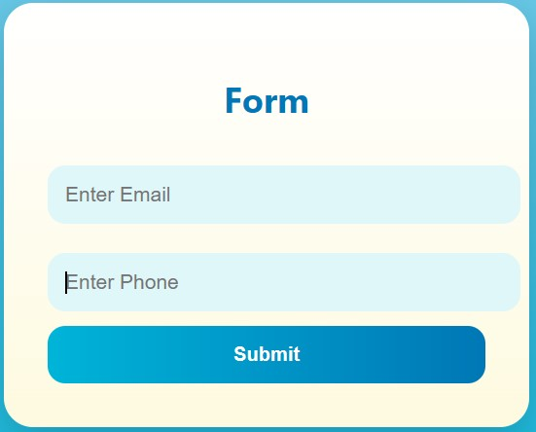

- Valid Input:
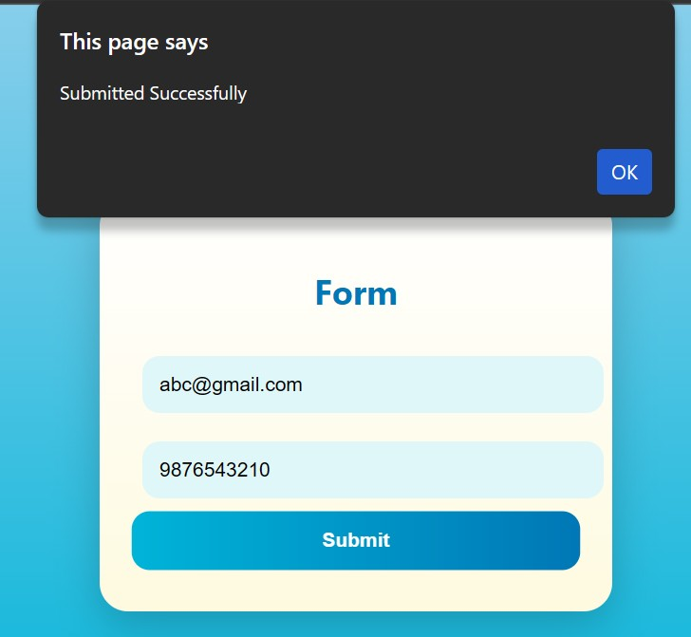

- Invalid Email:
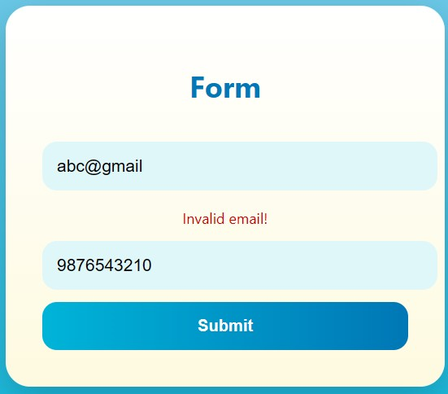

- Invalid Phone:
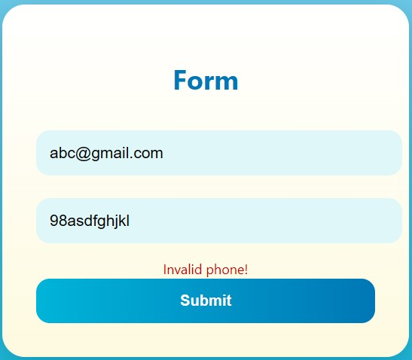

RESULT:
Thus, the input form was successfully designed using HTML, CSS, and JavaScript in a single file, and validation was performed using Validator.js to display appropriate error messages.

